Revision of Wiki Structure
- Major Sections to Remove from Wiki:
  - Remove WRT and HPIN Sections
  - At the very top level have:
    - How the system works/Introduction to the Microduino platform
    - There needs to be a top level instructional that shows the basics of ANY Microduino build
      - You need a Core
      - You program the Core
      - Peripheral devices communicate with the Core to create some sort of behavior
    - mCookie
      - Modules
      - KITS
      - Projects
    - Sensors
      - Modules
      - Projects
    - Microduino
      - Modules
      - Projects
- Navigation
  - Need to add top level breakdown of products into modules, projects and KITS (separately).
  - Breakdown each tutorial/project description into a page per section (see below):
  - 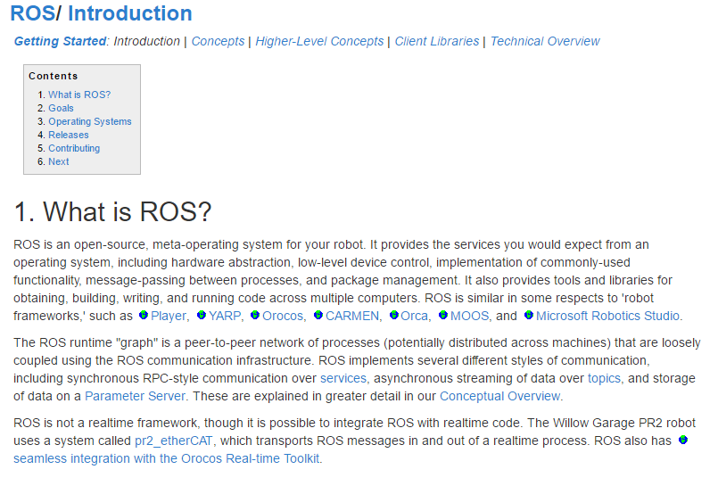
  - A top level navigation that nests a tutorial in a category (i.e. KIT or Project) will also help. 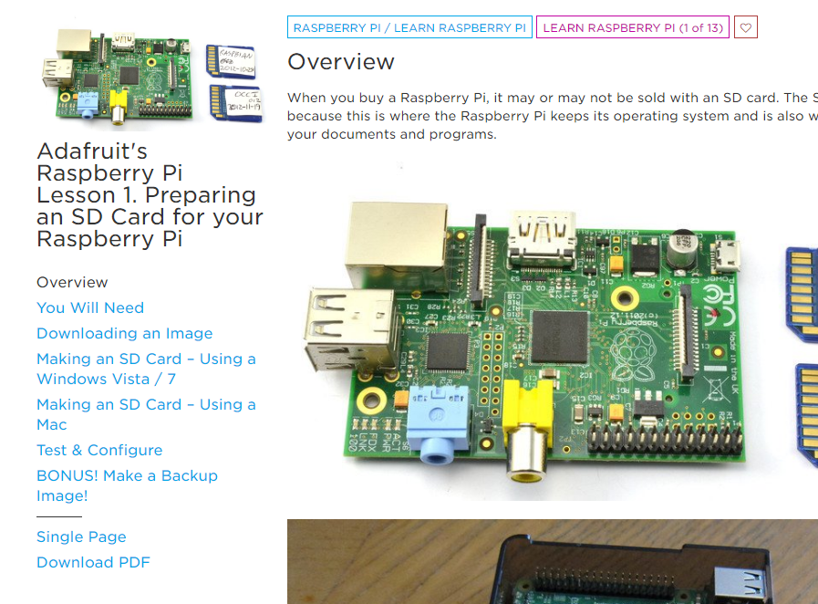
- There should be a sorting tool to find the reference you need
- Each reference link should be a picture, with a short title and description over the image.
- For a given tutorial, it would be useful to have images of the components used for a build:
  - 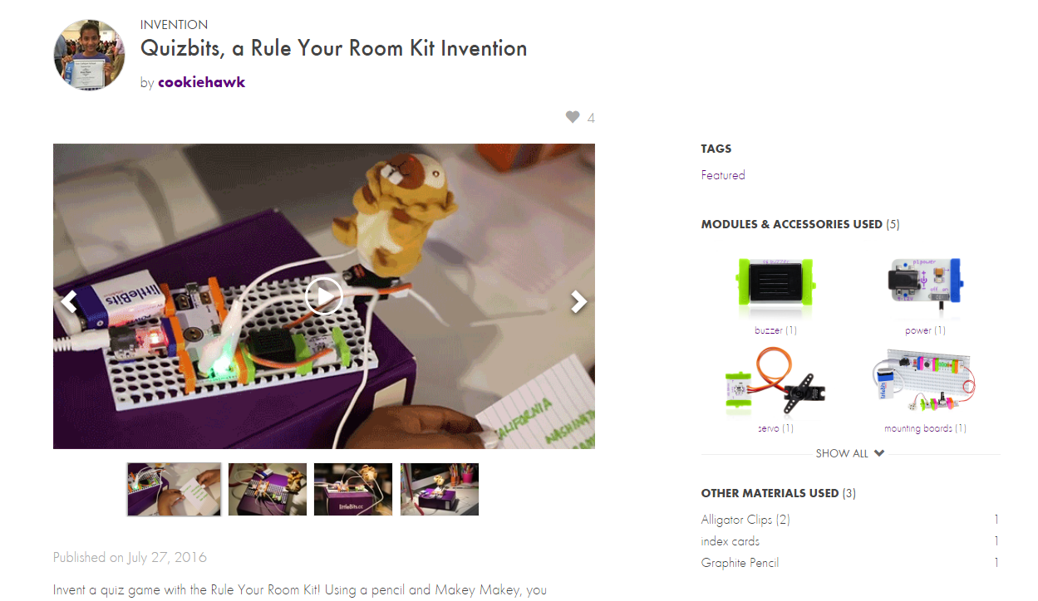

  - 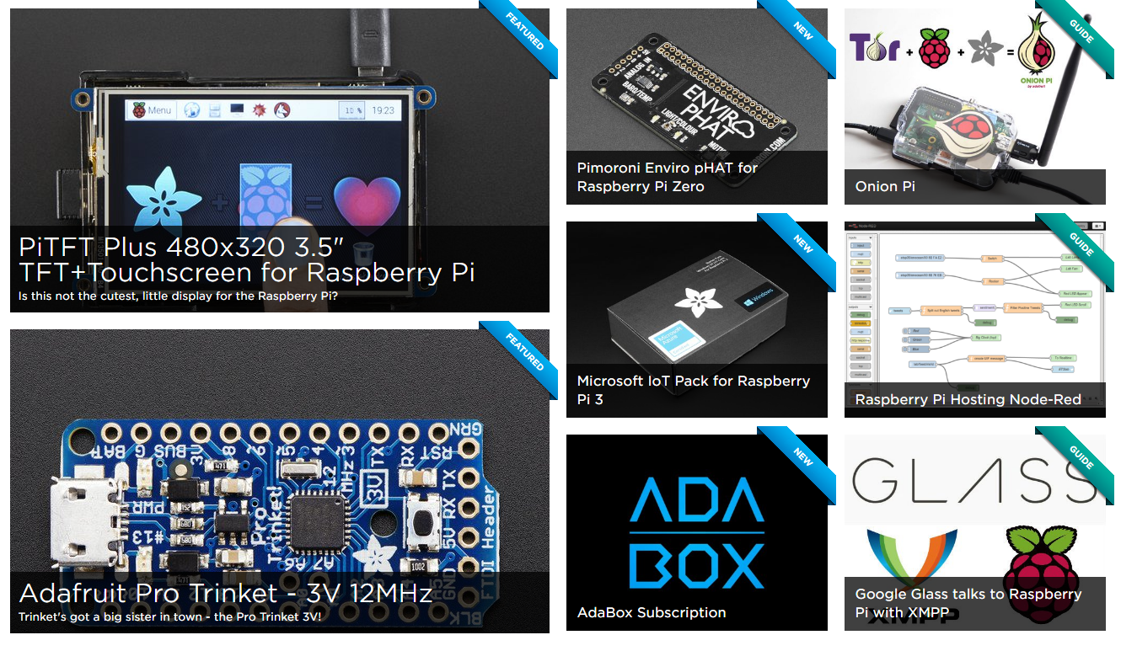If possible, animations would be cool

